Close your eyes.
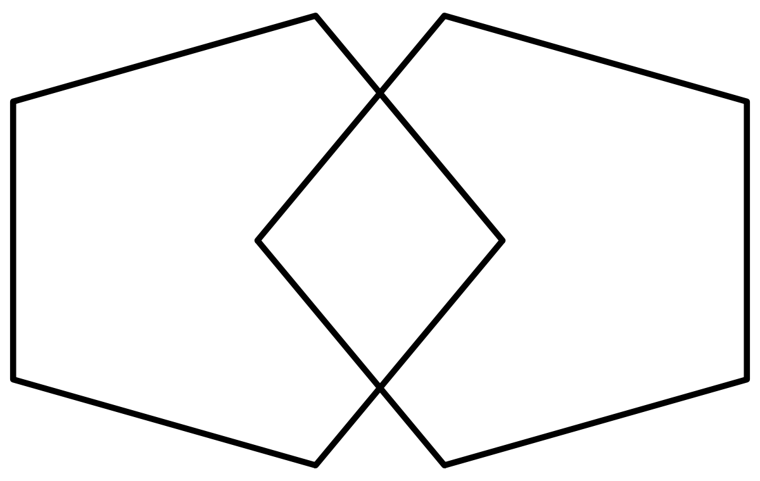

Here for the study?
Take a seat and the researcher will be right with you

